Dave and Plecs
When comparing the project implemented on the XMC4700 microcontroller using the DAVE environment with the one carried out on the Nucleo G474RE board using PLECS software, several important differences can be observed in terms of approach, complexity, and educational potential.
The implementation in DAVE proved to be simpler and more intuitive, especially from the perspective of users who are just beginning to work with microcontrollers. The tool provides a graphical interface and ready-made components, which significantly accelerates the software development process and reduces the risk of errors.
On the other hand, working with the Nucleo G474RE microcontroller in combination with PLECS requires greater involvement from the user, particularly in creating the program structure. Although this approach demands more time and technical knowledge, it offers a better understanding of how individual system components work and how they interact with each other. Developing in PLECS also enables the creation of more flexible and advanced solutions. Additionally, it allows code generation for STM32CubeIDE, which makes the integration with STM32 development tools more seamless.
In summary, DAVE with XMC4700 offers a faster and more user-friendly solution for practical project implementation, while PLECS with Nucleo G474RE provides deeper insight into system behavior—an especially valuable aspect from the perspective of learning, analysis, and optimization of engineering systems.
Below is a description and presentation of the programs developed in both environments — DAVE and PLECS. Each of them offers a different approach to project implementation, both in terms of development proces.

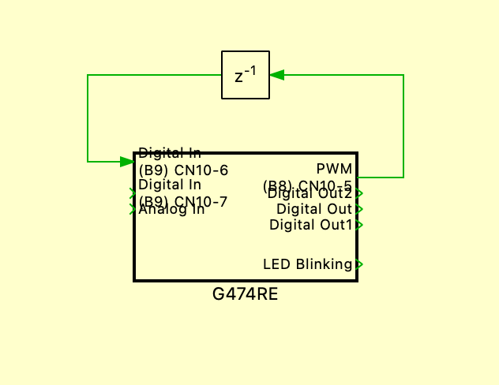
PI CONTROLLER PLECS
The program was created in the PLECS environment and implemented on the STM32 Nucleo G474RE microcontroller. It is designed to control a DC motor using a PI controller. The system simulates a closed-loop speed control, comparing the actual motor speed with a reference speed. The first step is to create a subsystem block with delay.

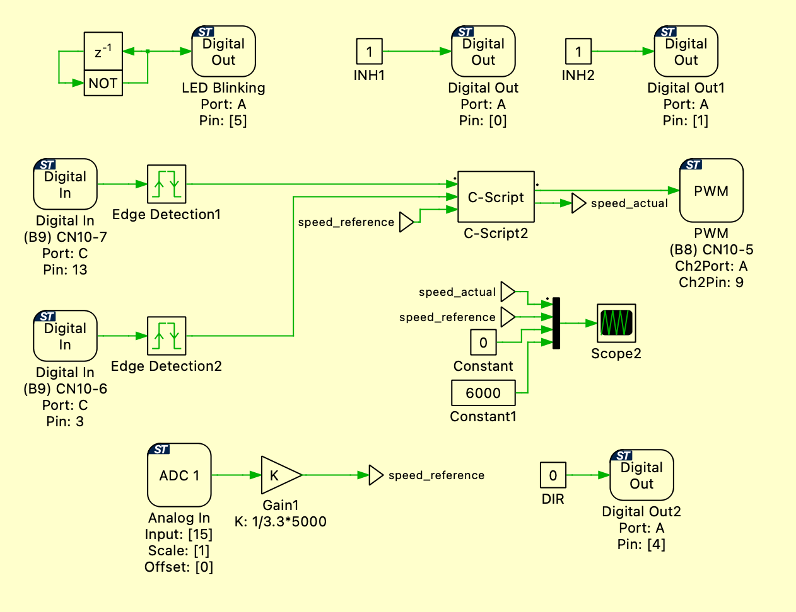
This is how the program looks inside the subsystem. The following sections will provide a detailed explanation of its individual components.
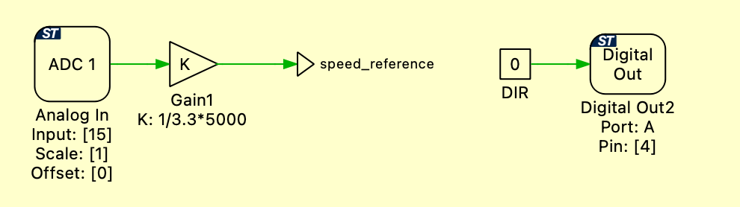
Analog In ranges from 0 to 3.3 V, and we can modify this value by adjusting the potentiometer's setting. Then, divide the reading by 3.3 and multiply it by 5000 to obtain the maximum speed value. DigitalOut2 is set to a constant value of 0, which means that the direction of the motor’s rotation remains unchanged.

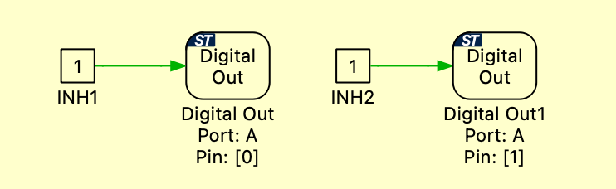
DIGITALOUT and DIGITALOUT1 are set to a constant high (logic 1), which means that the INH1 and INH2 channels of the High Current Half-Bridge are always enabled.
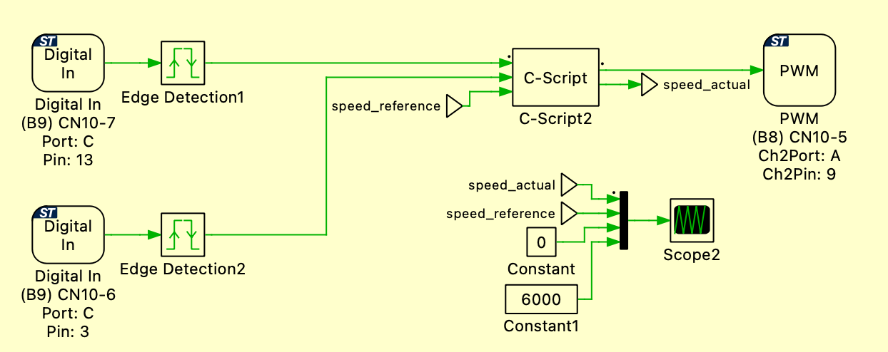
At the beginning, we have two Digital In signals connected to the motor phase outputs. These signals are then passed to an edge detector that detects both rising and falling edges. The detected edges are then sent to the C-script block.
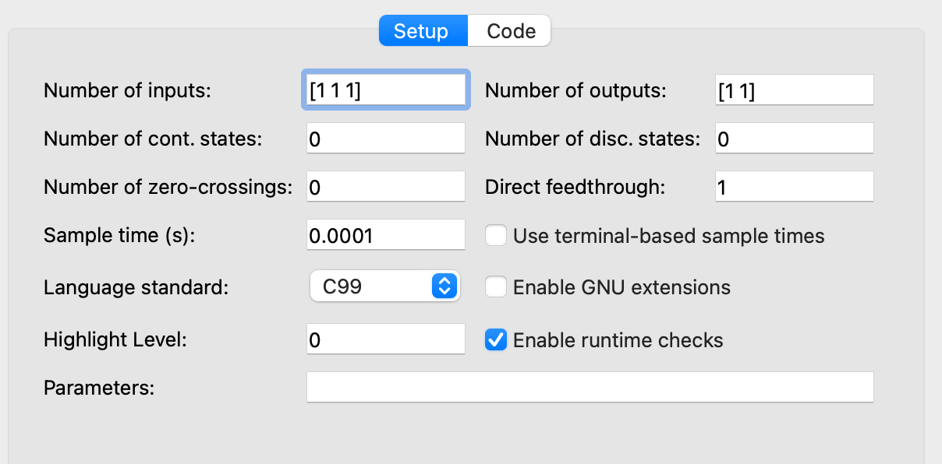
Three inputs are defined. Two of them are signals from edge detectors, and the third is the speed reference value previously read from the Analog In input. Additionally, we define two outputs: one is a PWM signal responsible for controlling the motor, and the other is the actual speed (speed_actual). This output is provided to allow visualization on a graph of the difference between speed_reference and speed_actual. The sample time is set to 0.0001 seconds, which corresponds to a frequency of 10 kHz

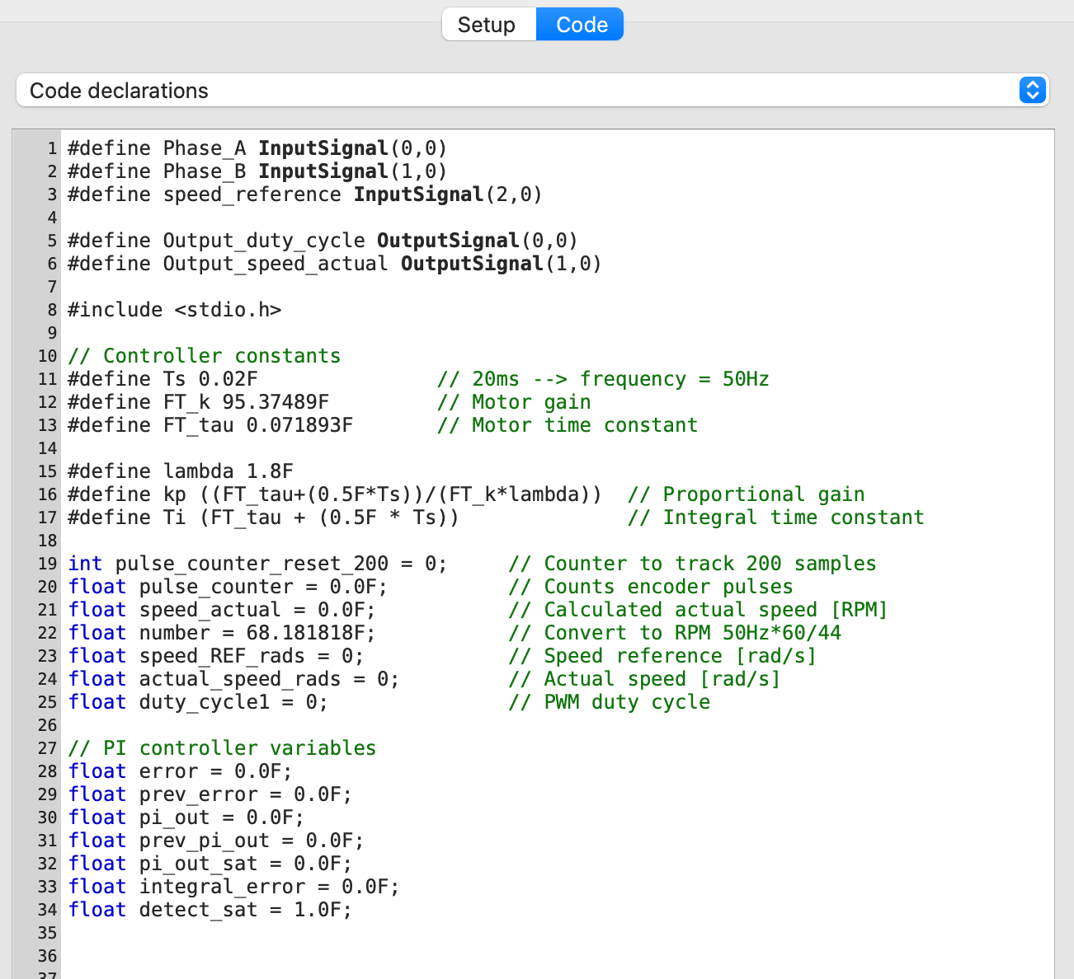
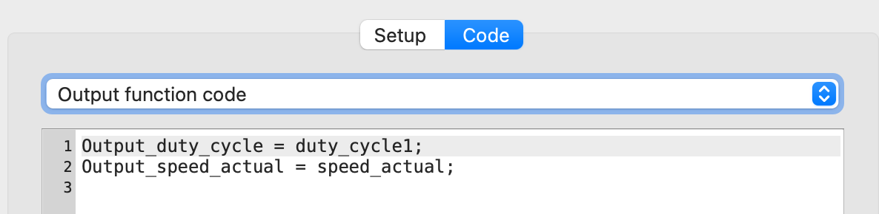
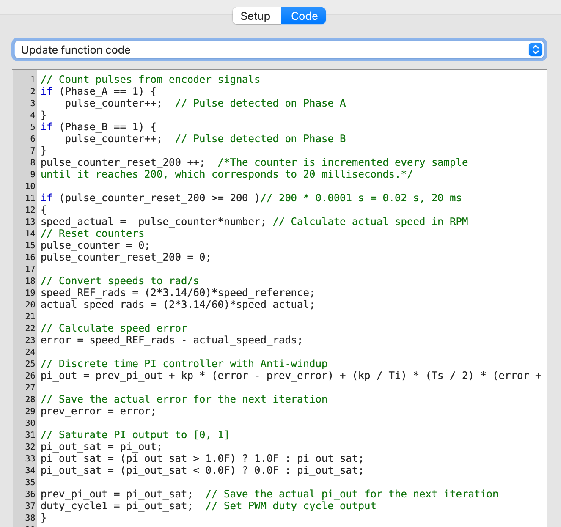
Two digital input signals are processed to count pulses, which allows calculating the actual rotational speed of the motor. Every 200 samples (i.e., at a specified time interval), the speed is calculated in RPM and then converted to radians per second.
The speed reference value (Speed Reference) is read from an analog input and also converted to rad/s. The PI controller compares the reference value with the actual speed, and the control output (duty cycle) is limited to the range [0, 1] and sent to the PWM output, which directly controls the motor operation. Additionally, the speed_actual output enables real-time visualization of the actual speed.

The charts present the reference speed and the actual speed. It can be seen that both values are close to each other.

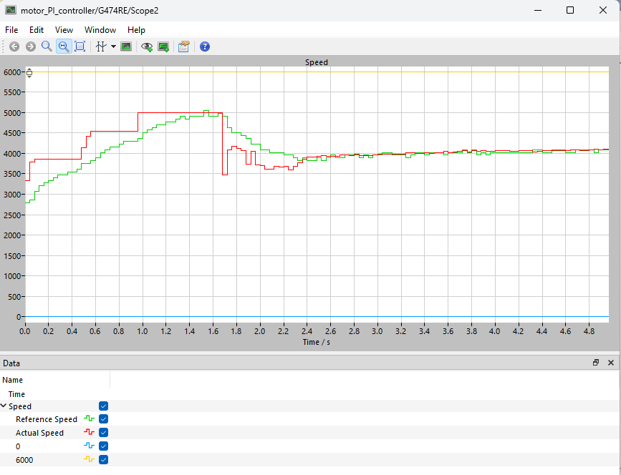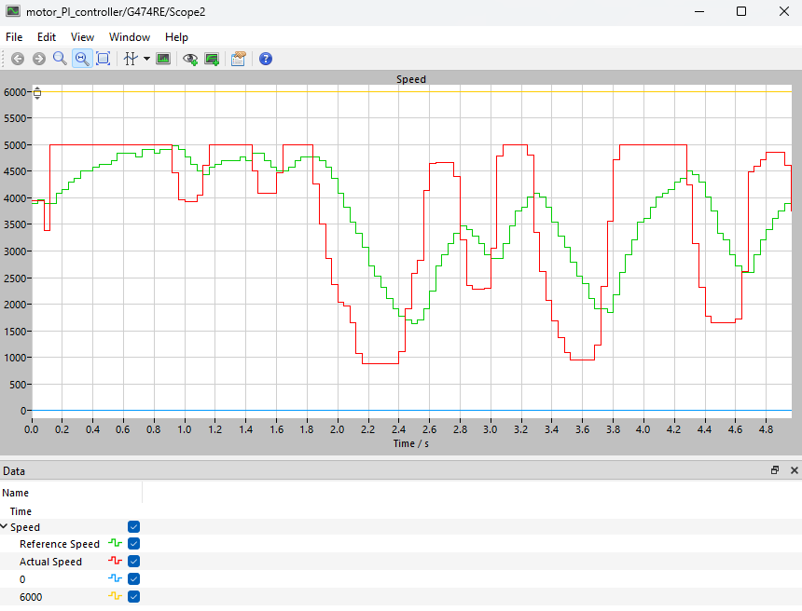
PI CONTROLLER DAVE
Just like in the PLECS environment, the program was also developed in the DAVE environment. The source code is practically identical, meaning that the logic and implementation of the PI controller and speed measurement were transferred without significant changes. The program in DAVE works correctly, and the results obtained during testing match those achieved in PLECS. This confirms that the implementation is stable and effective on both platforms. Below are the graphs illustrating the program’s operation and comparing the speed reference with the actual speed.

